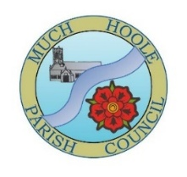 | DRAFT Minutes of Much Hoole Parish Council meeting held on Monday 8th July 2026 at 7.30pm at The Venue at Hoole Village Memorial Hall, Liverpool Old Road, PR4 5QA.

Present: A. Taylor (Acting Chair), R. Lea, E. Jackson, E. Houghton, P. Cocker, T. Hewitt, and Acting Clerk Mr. P. Cafferkey.
- Apologies for Absence
Cllrs K. Hayes (Chair) and P. Fox.

- Declaration of Interest and Dispensations
Cllrs E. Houghton and A. Taylor declared a non-pecuniary interest in agenda item 6b.

- Minutes of the Previous Meeting
It was resolved that the minutes of the meeting held on 10th June 2026 were agreed to be a true and accurate record. Proposed by Cllr E. Houghton, seconded by Cllr E. Jackson and agreed unanimously. The Chair signed the minutes.

- Public Time
No members of the public were present.

- Correspondence from members of the public.
Two items were received from members of the public.
Item 1: Correspondence had been received from a member of the public about HGVs using Brook Lane between the A59 and Liverpool Old Road. It was resolved that the Acting Clerk would write to Lancashire County Council Highways to see if some signage could be erected to discourage HGVs from using this small section of residential road. Proposed by Cllr E. Houghton, seconded by Cllr P. Cocker, agreed unanimously.
Item 2: The hedgerow overgrowth has been cut where Brook Lane meets Liverpool Old Road, but it is still considered to be encroaching onto the footpath, as are number of other hedgerows in the vicinity. It was resolved that the Acting Clerk would write to Lancashire County Council regarding private residential hedges restricting access on footpaths, especially for people pushing prams. Proposed by Cllr T. Hewitt, seconded by Cllr. E. Jackson, agreed unanimously.

- Reports from other meetings and information on future events
LALC (Lancashire Association of Local Councils). Cllr E. Houghton reported that she had attended an Executive Committee meeting of LALC but that there was nothing of specific relevance to report back to Much Hoole Parish Council.
- Village Hall The Council noted Cllr A. Taylor’s report on the Village Hall. He informed the Parish Council that the Classic Vehicle event will take place in August. A regular swing band event has started and there are regular ongoing organ concerts. Pickleball is underway on the tennis courts. The management group is awaiting the planning outcome of the Padel court proposal and is still looking for further funding for rebuilding the bowling pavilion. The Men’s shed project is due to start in September. All regular activities are well attended, and the recent AGM reported a good financial position.
- Off Road Cycle Track
- Cllrs A. Taylor and R. Lea reported that inspections had been undertaken, no problems identified other than a bit of litter including some drink cans that had been torn in half exposing sharp edges to other users of the track.
- “No E bike Use” signage. This matter had been reported complete at the June meeting.
- Finance
- The Clerk reported that Section 2, Box 11, of AGAR (Annual Governance & Accountability Return) 2025/26, had erroneously not been completed by the Clerk when it was approved at the June 2026 meeting. This was now resubmitted for approval, with Box 11 completed. It was resolved that Section 2 of the AGAR now be re-approved, with Box 11 now completed. Proposed by Cllr R. Lea, seconded by Cllr E. Houghton; agreed unanimously.
- It was resolved to sign off the Bank reconciliation for the month of June 2026, signed by Cllr E. Jackson and unanimously agreed.
- The Council noted the Clerk’s financial statement as at 30 June 2026.
- It was resolved to authorise the following payments, proposed by Cllr E. Houghton, seconded by Cllr P. Cocker and unanimously agreed:
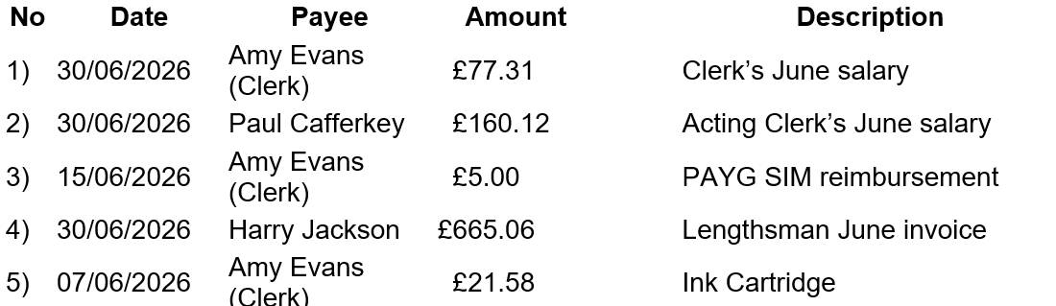
- Annual Governance and Accountability Return (AGAR) 2025/26 & Dates for Exercise of Public Rights
- The Acting Clerk confirmed that the AGAR had been submitted by the required deadline.
- The Acting Clerk confirmed that the dates for the exercise of public rights had been published and the dates start on Friday 29th June 2026 and end on Friday 7th August 2026.
- Footpaths and Gardens
Cllr P. Cocker reported the following with regard to Public Rights of Way (PRoW).
- Lancashire County Council has carried out clearance work on the large Public Right of Way (PRoW) footpath 001. The Parish Council Lengthsman has also been addressing several overgrown footpaths previously raised by a member of the public (Mr. Steven Smith), minute reference 10 June 2022: 5.1. Mr. Smith has provided voluntary assistance in clearing some of the overgrown PRoWs, and the Parish Council expressed its thanks for his public-spirited contribution. FP19 has been subject to fly tipping which SRBC are in the process of removing. Cllr P. Cocker suggested a post could be erected near to the entrance of the PRoW to discourage future fly tipping problems. Cllr P. Cocker will try and speak to the land owner. FP10 is affected by an overgrown hedge which Cllr P. Cocker will report to Lancashire County Council.
- FP26: Cllr P. Cocker is to try and speak to the landowner, or farm tenant, with regard to overgrowth on the footpath. FP 27: the affected area has now been fenced off by the landowner meaning that livestock is now separated from the path.
- Covered under item a) above.
- Children’s Playground: South Ribble Borough Council is repainting the playground, and it should be completed by the start of the school summer holidays.
- Damaged Bench on Brook Lane: Still awaiting a response from Lancashire County Council via the Love Clean Streets app.
- Replacement Bus Shelter
The new bus shelter purchased by the Parish Council has now been installed on Liverpool Old Road near to the A59. And, Lancashire County Council has also installed a new more up-market bus shelter on Liverpool Old Road near the Smithy Inn.
- Newsletter & Business Directory.
Cllr R. Lea had obtained quotes from Preston City Council of £225 (VAT exempt) for the printing of Newsletter and £182.50 (VAT exempt) for the printing of Business Directory. It was resolved that these quotes be approved. Proposed by Cllr E. Houghton and seconded by Cllr T. Hewitt; agreed unanimously. The Parish Council thanked Cllr R. Lea for his work on this.
- Planning
Ref | Address | Description
07/2026/00349/FU | 25 Smithy Lane Much Hoole PR4 4GN | new detached true bungalow on the garden to the rear of 25 Smithy Lane
07/2026/00403/HOH | 197 Liverpool Old Road Much Hoole PR4 4GB | Demolition of outbuildings and erection of detached permanent annexe within residential curtilage
The Parish Council had received an objection with regard to item 07/2026/00349/FU above. The Parish Council had previously objected to a similar application (07/2024/00172/FUL) at the same address, which had been refused by South Ribble Borough Council. Whilst the Parish Council acknowledged the new application is for a “true” bungalow as opposed to a dormer bungalow which was previously refused, the Parish Council still considered the footprint very similar in size and as such was being “shoehorned” into what is essentially a back garden. It was resolved, therefore, to object to this planning application (07/2026/00349/FU) along the lines of the previous planning application (07/2024/00172/FUL); proposed Cllr E. Houghton, seconded Cllr E. Jackson, and unanimously agreed.
- Items for next agenda
- Purchase of bench for corner of Brook Lane / A59 depending on outcome of LCCs response to Love Clean Streets App submission.
- Patch of land near planters – need to tidy up.
- Date of next meeting
The Council unanimously agreed the date of the Sept meeting as 7.30pm on Wednesday 9th Sept 2026 at ‘The Venue’, Liverpool Old Road, Much Hoole. NB no meeting in Aug. The meeting closed at 20:20.

